**MASEERA SHAIKH: ETHICAL HACKING INTERNSHIP TASK 1**

Lab 1: Reflected XSS into HTML context with nothing encoded

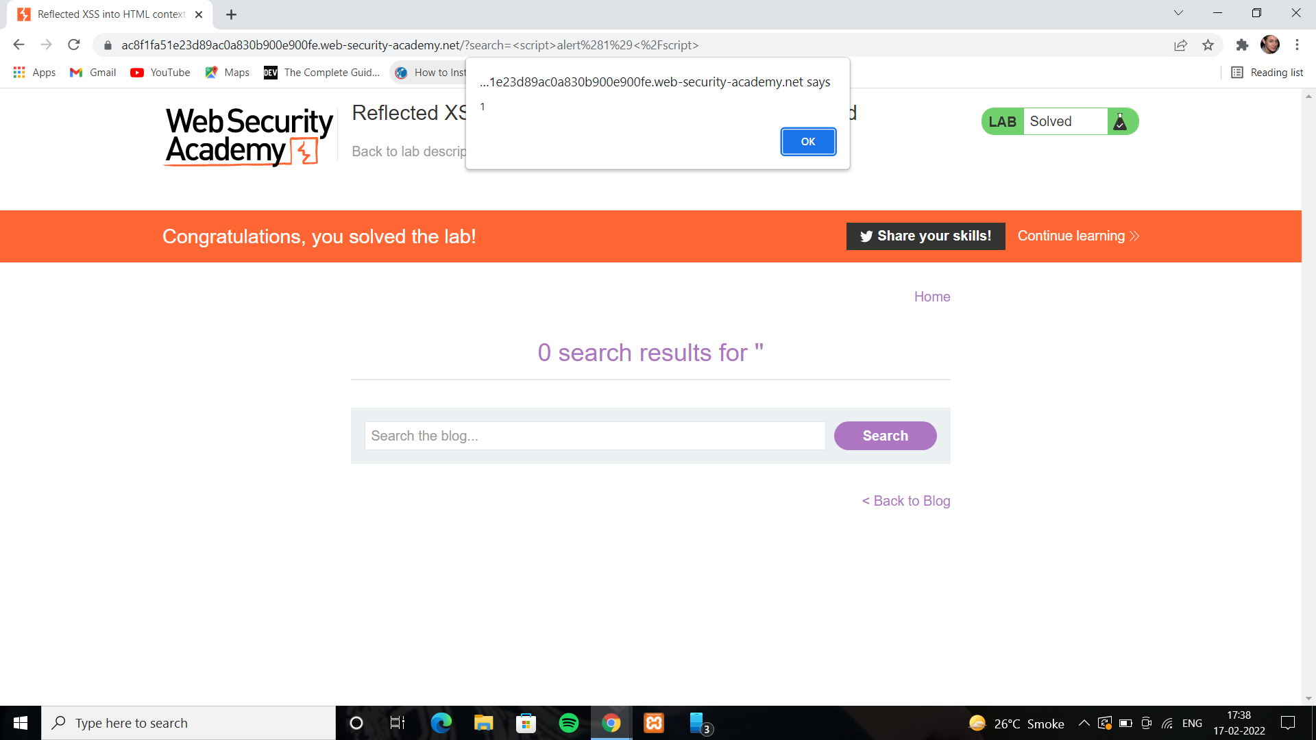

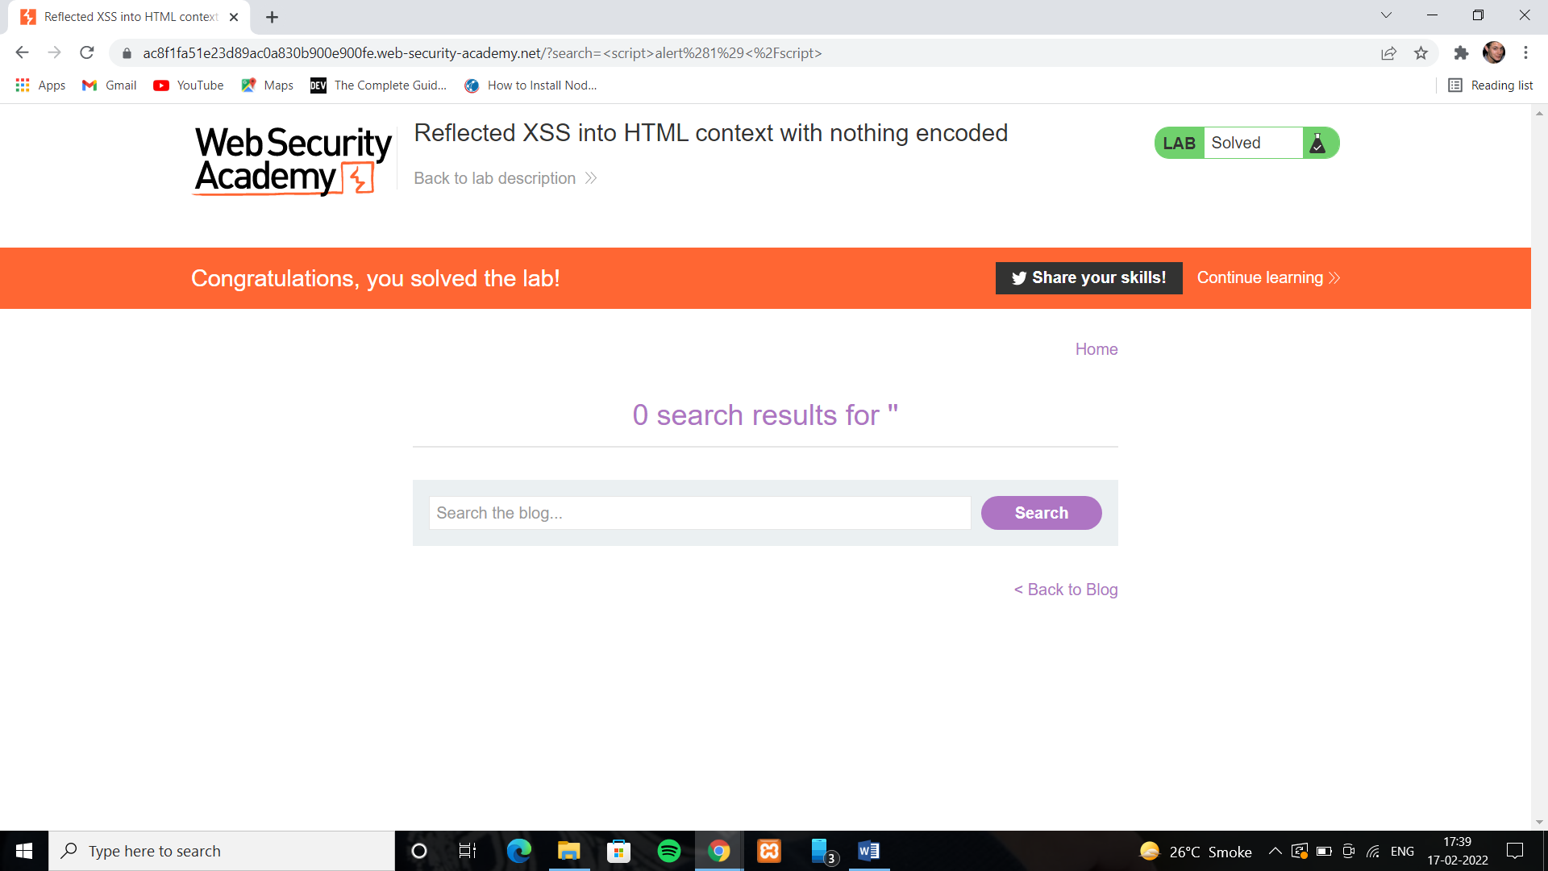

Lab 2: Stored XSS into HTML context with nothing encoded

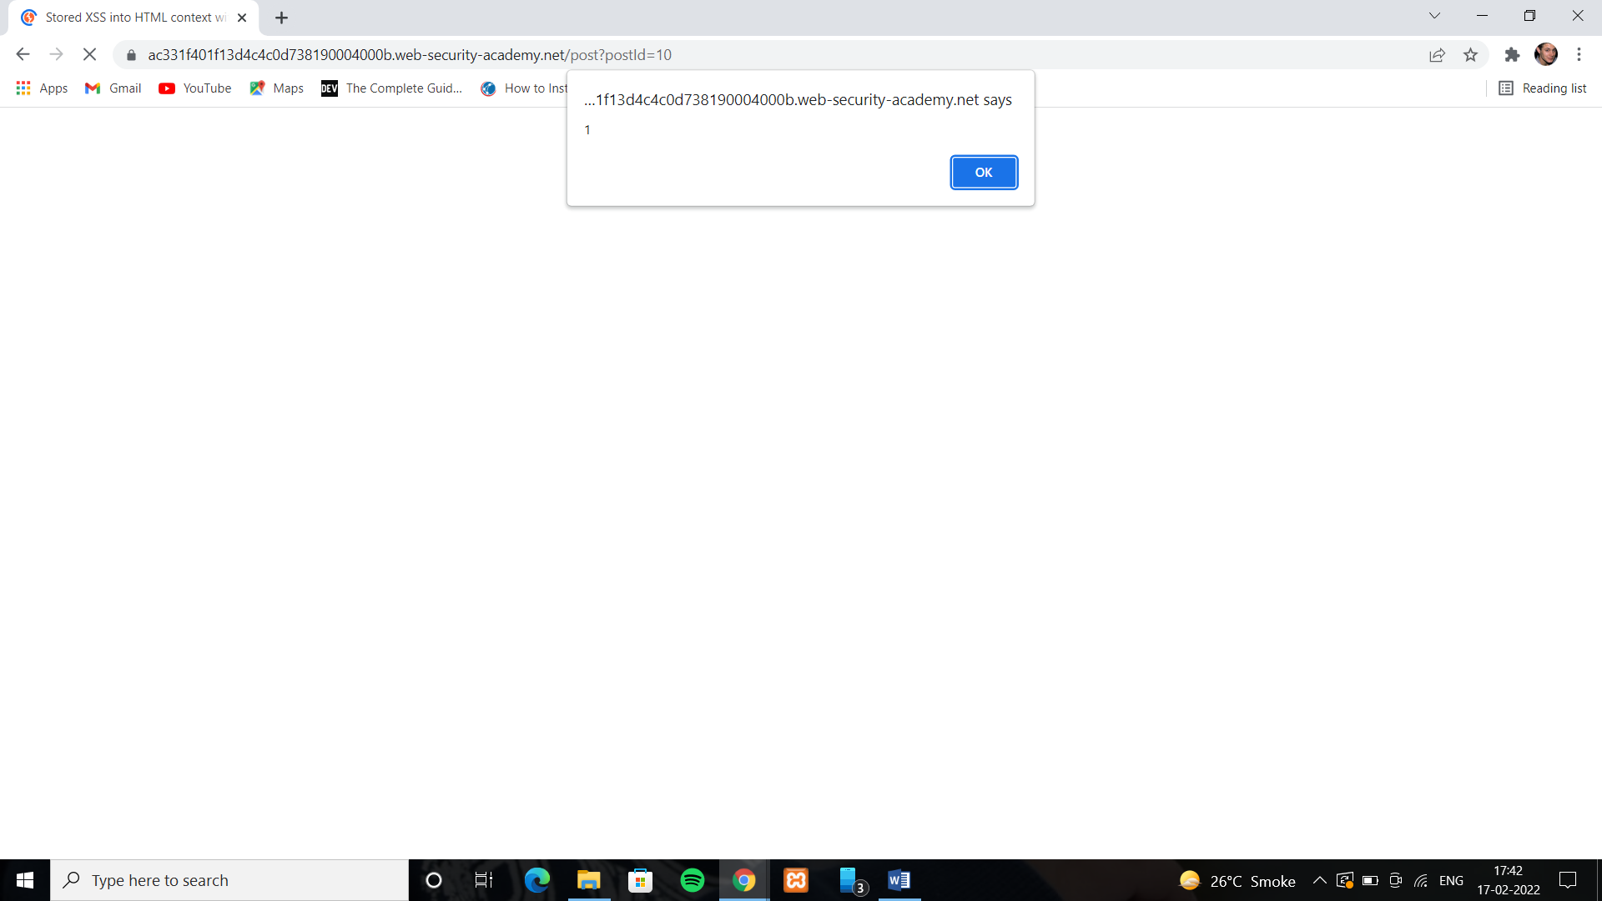

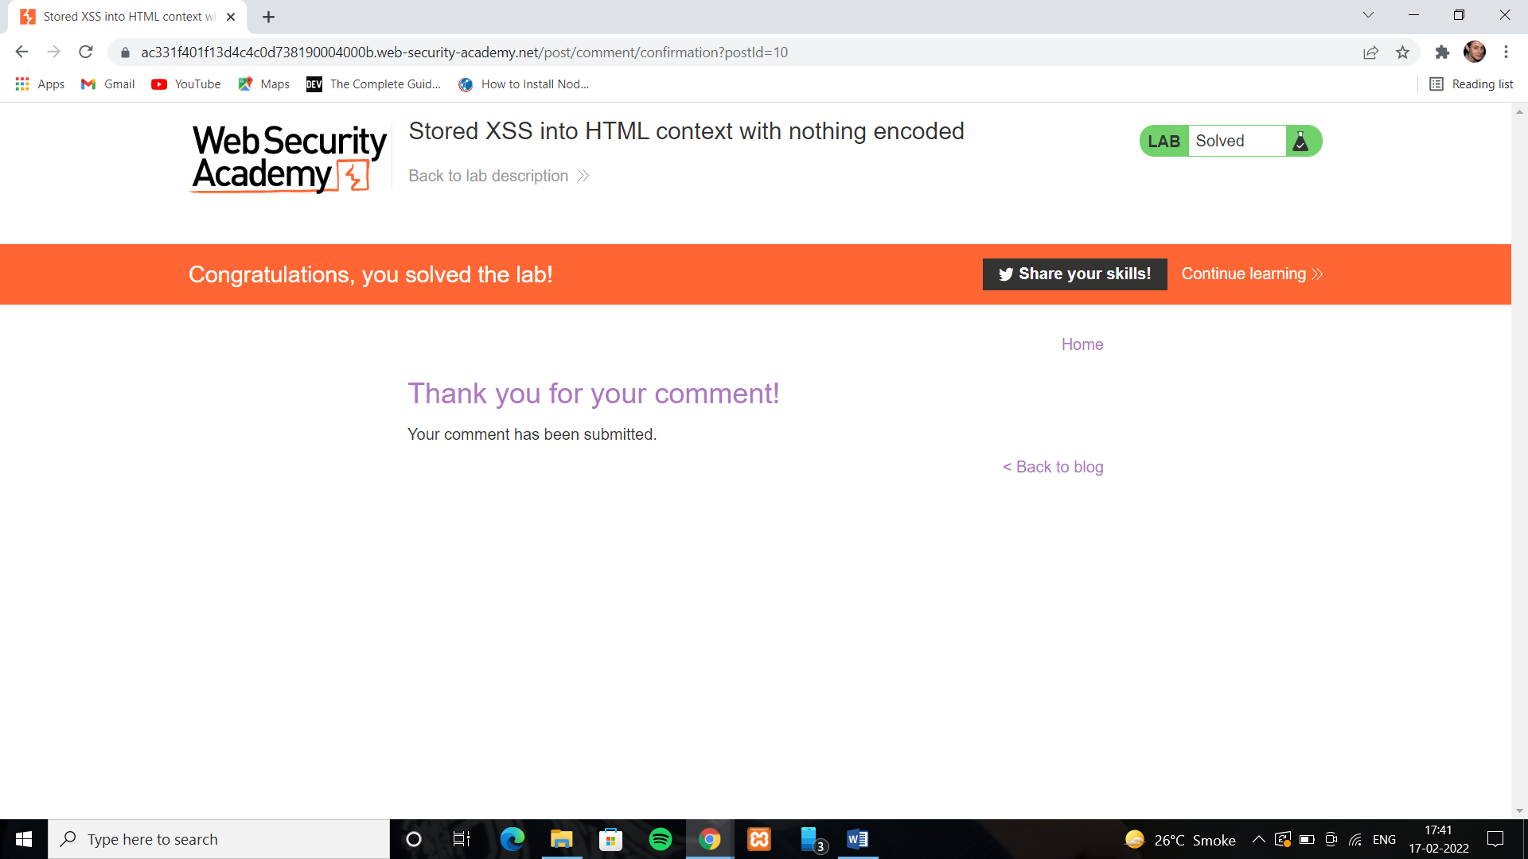

Lab 3: DOM XSS in document.write sink using source location.search

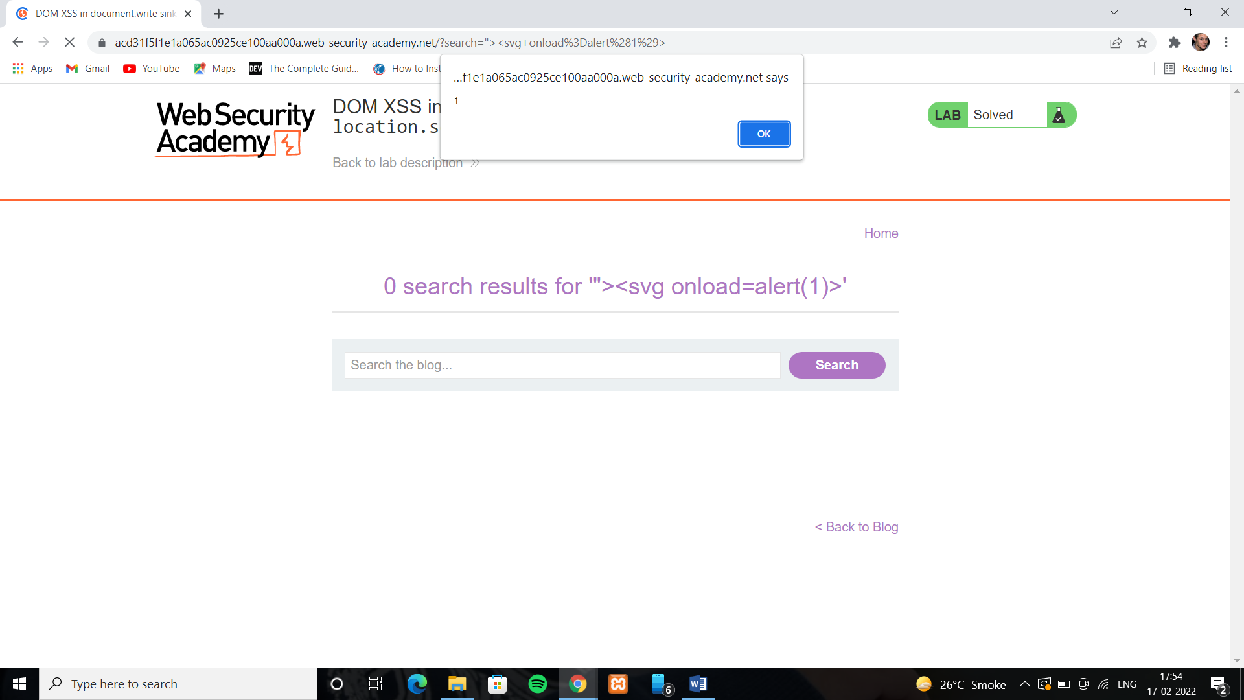

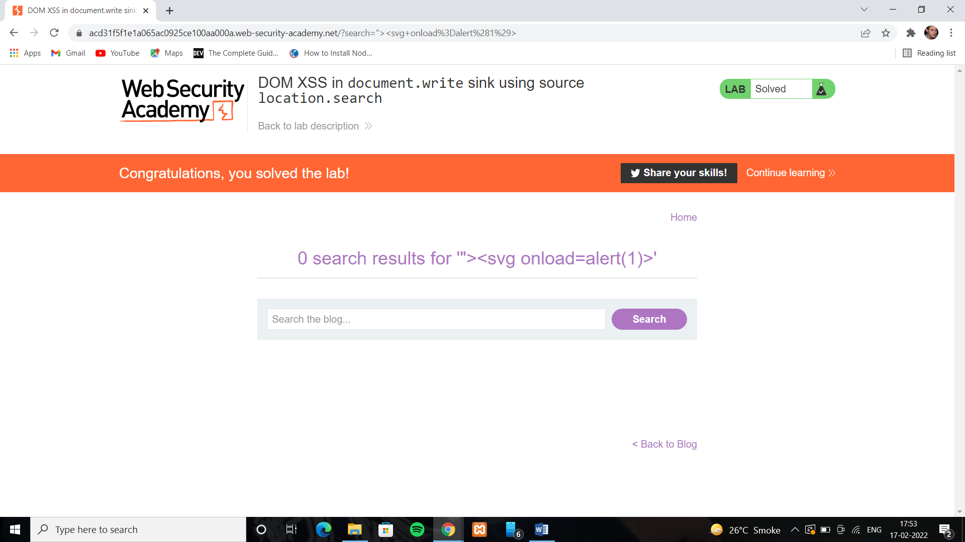

Lab 4: DOM XSS in innerHTML sink using source location.search

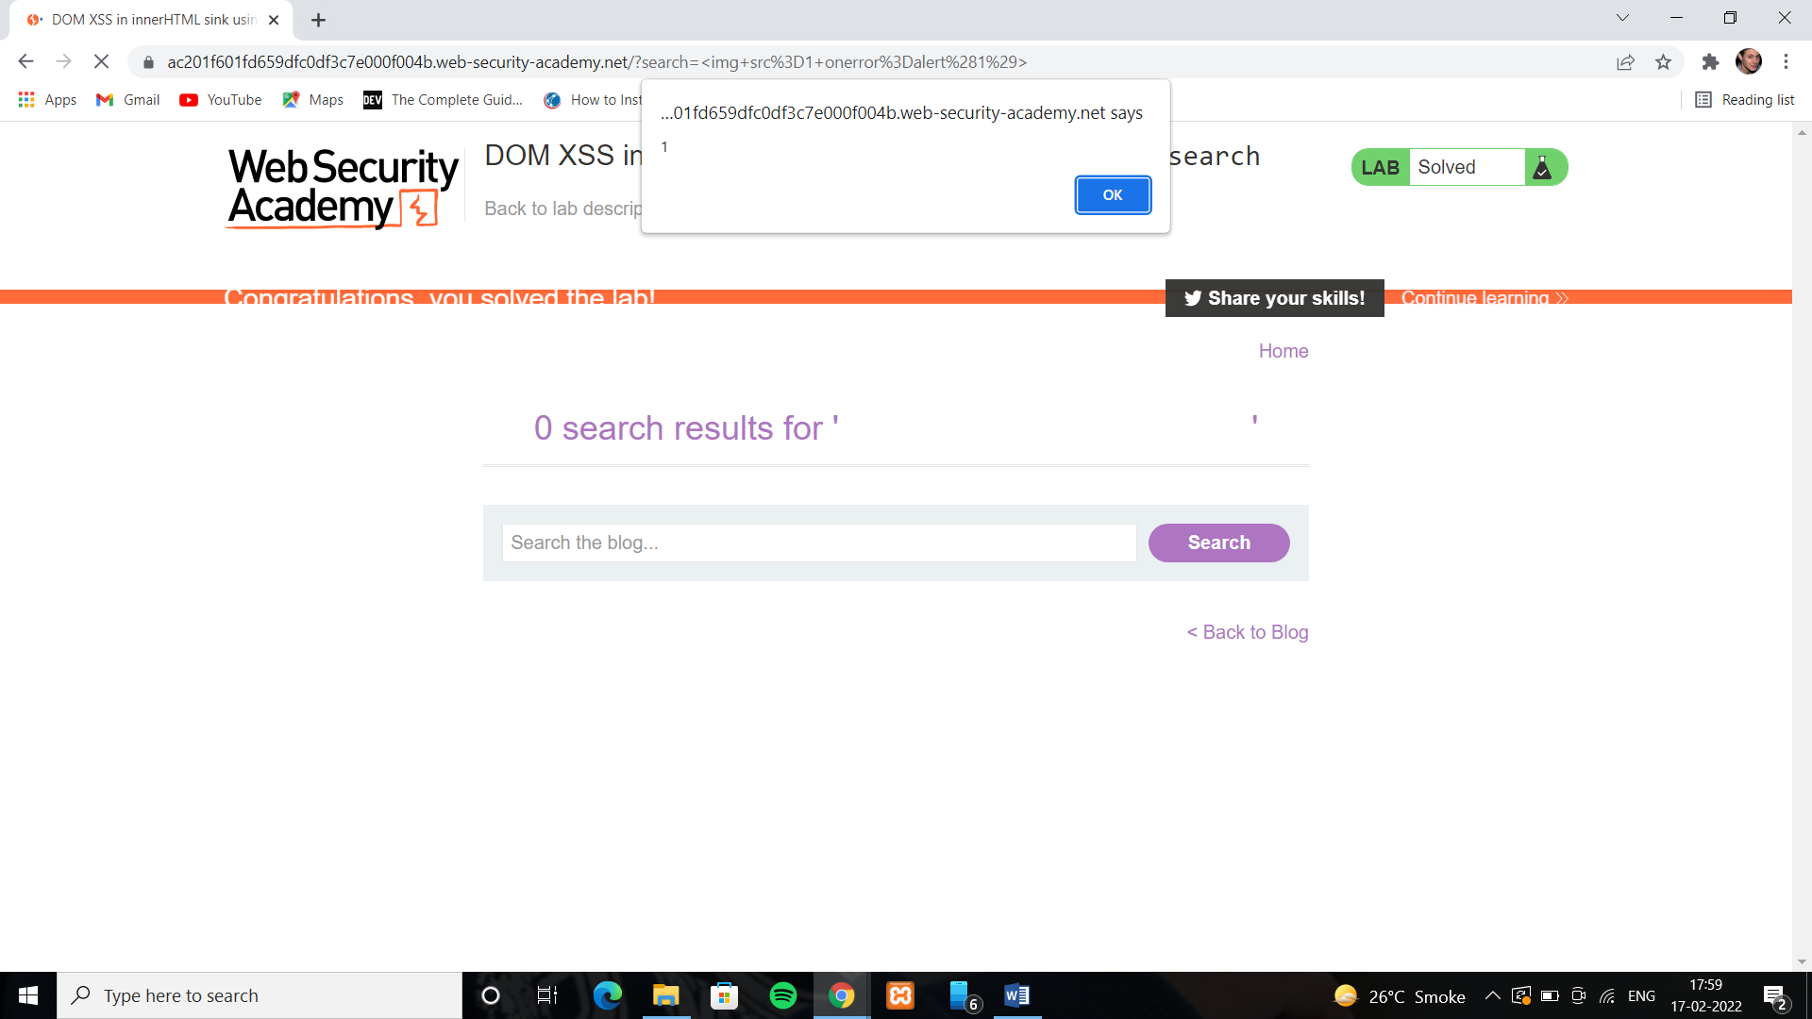

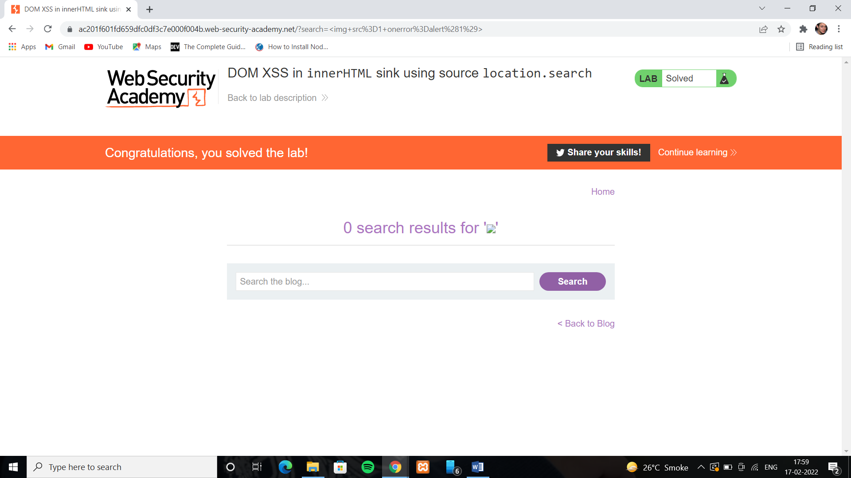

Lab 5: Reflected XSS into a JavaScript string with angle brackets HTML encoded

